Some words about me:
Łukasz Maurycy Stanaszek, Ph. D. (maurycystanaszek@wp.pl)
Head of Anthropological Laboratory, State Archaeological Museum, Warsaw (Poland)
My family Stanaszek (Stanke) belong to R1a-S18681 clade. I am an admin of Urzecze Project (http://www.familytreedna.com/public/otwock) connected to small ethnographical micro-region on the banks of Vistula river near Warsaw which is called “Urzecze” (The Vistulan Riverside).

R1a-S18681
Z282>Z280>CTS1211>CTS3402>Y33>CTS8816>S18681
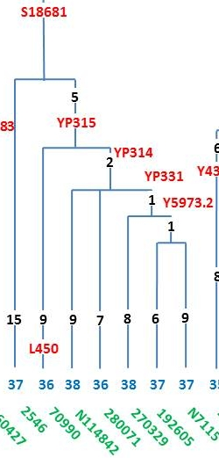
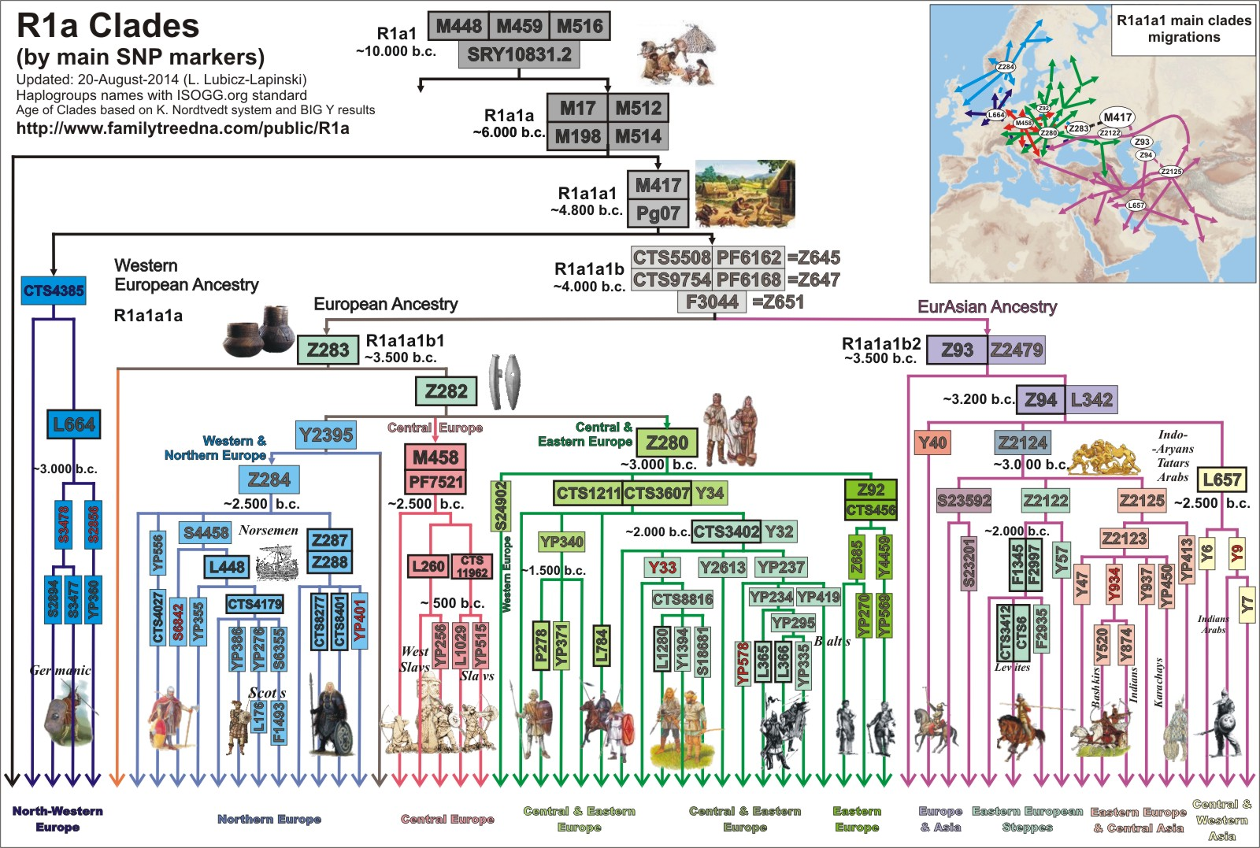
The chart is a simple, basic version of the actual SNP tree depicting clade positions and relations as well as approximate dates and probable ethnic or geographical spread (made by L. Lubicz-Lapiński, https://www.familytreedna.com/public/r1a/default.aspx)
Version 11 4-Nov-2014
CLADE R1a-S18681 ORGIN...

R1a-S18681 is a brotherly clade to L1280 (mostly Central-Southern Europe) and Y1394 (Volga-Carpathians) and is dated circa 2,000 years. They all belong to CTS8816 which lay under southern Baltic CTS3402 branch (see chart above) of R1a haplogroup.

Clade R1a-S18681 is not so huge against a background. It concentrate in particular in North-Eastern Germany and Western-Central Poland. A few samples are from Ukraine.

If the older subclades (S18681*) will be from Ukraine or/and Eastern Poland and the YP314 will be in the majority from Germany we would have a quite clear ethnogenetic situation. It shows trajectory of migration from Ukraine, via Poland to Germany. This brilliantly correlate to early germanized Polabians who settled in present Germany from 6th century (http://en.wikipedia.org/wiki/Polabian_Slavs). But Polabians were also differentiated and often fight with one another... Individual tribes were sometimes related very, very far (R1a-M458 vs. R1a-CTS3402 branches) and we don’t know exactly about their real orgin (Slavs or just Indo-Europeans, indigenes...?). For the time being small clade S18681 fits exactly to brave northern Rani (http://en.wikipedia.org/wiki/Rani_%28Slavic_tribe%29), because of samples from British Island (we know that in Middle Ages they were an excellent sailors) and probable genealogy of some families connected with Rügen and Mecklenburg (Runge, Stahnke, Blancke/Blanckenberg, von Pegelow)
The YP331 subclade - which coming up straight into western "German" YP314 - might be connected with German settlers from Poland & Ukraine, like Vistulan "Dutch settlers" (http://en.wikipedia.org/wiki/Ol%C4%99drzy). If the YP314 would have the western orgin, the YP331 had it as well.

But of course will see how it goes :))

More Information About R1a-S18681
http://www.gwozdz.org/PolishClades.html#IType

BASIC REQUEST TO CLADE S18681 MEMBERS
Please join to R1a and Subclades Y-DNA Project (https://www.familytreedna.com/public/r1a/default.aspx) and support investigations on our S18681 clade. To do this You have to:
1.Login on your FTDNA profile site (kit number, password, https://www.familytreedna.com/login.aspx)
2. On the top you will find overlap "Projects" go in and choose "Join", then find "Y-DNA HAPLOGROUP PROJECTS" and letter "R" go in and select project "R1a1a and Subclades" (containing more than 3200 persons), go in and JOIN.
3. Later You can find your kit sample and results on Project chart: https://www.familytreedna.com/public/r1a/default.aspx?vgroup=r1a&section=yresults

RECOMMENDATIONS FOR CLADE S18681 MEMBERS

BIG-Y
The best way to recognize Your real place on S18681 tree is to order a BIG-Y test, which you can find on FTDNA personal site (https://my.familytreedna.com/big-y.aspx?ekit=upRokOdEvjM%3d). Of course it is quite expensive – 595$, but – definitely it is worth. To date from our S18681 clade seven persons ordered Big-Y (Dąbrowski, Gemega, Hübner, Piasetzki, Runge, Śliwiński, Tafel).

FGC
Very important for our S18681 clade is to test even ONE person by most expensive (850$) and most precise Full Genomes Corp. test (FGC, https://www.fullgenomes.com/). We would know much more about real relationships between brotherly clades: S18681, L1280 and Y1394 (Volga-Carpathians). We already have FGC tests of L1280 and Y1394 and they have 2 common SNPs more (but we don’t know if the same way would be with S18681...).

SNP ORDERS
The cheapest and very good way to know more about our paternal ancestors is to place an order of some useful SNPs. There are 4 available and recommended SNP’s (S18681>YP315>YP314>YP331):
- YP331 (downstream from YP314) – you should order it first
- YP314 (downstream from YP315 and upstream from YP331) – you should order it second, if YP331–
- YP315 (downstream from S18681 and upstream from YP314) – you should order it third, if YP314–
- S18681 (subclade of CTS8816, disjoint from Y1394 and L1280) – you should order it at the and if YP331–, YP314– and YP315–

To order above SNP’s you have to login on your FTDNA site (kit number, password; https://www.familytreedna.com/login.aspx) and choose top right "Order An Upgrade", then choose "Order an Advanced Test" and choose Test type [SNP] and then find or write S18681 or/and YP315, YP314, YP331. Total cost is 39$ per one SNP (you don’t need to swab again!).

CHART OF CLADE S18681 MEMBERS (please add and correct all information below)

SUBCLADE | Kit | Name | Ancestors | e-mail
S18681*
S18681+  YP315-  (BIG-Y tested) | 2546 | PIASETZKI | Johann Piasetzki, b 1860 Sensburg East Prussia | gpiasetzki@pnklaw.ca
S18681+  YP315-  YP314-  YP331-  L450- | N52259 | IWANOWICZ | Jan Iwanowicz born 1790 Chojniki, Poland | pete2g@comcast.net
S18681+ YP315-  YP314-  YP331-  L450- | N52262 | IWANOWICZ | Iwanowicz born about 1800 west of Ostroleka, Poland | pete2g@comcast.net
S18681+ YP315-  YP314-  YP331- | E2665 | SKRIPKA | Skripka Mihail, geb.ca. 1670, Ukraine | scheiermann@gmx.de
S18681>YP315
S18681+  YP315+  L450+  YP314-  YP331-  (BIG-Y tested) | 70990 | ŚLIWIŃSKI | Aleksander Sliwinski, b.1898, Grzymkowice, Poland | robert_sliwinski@sbcglobal.net
S18681+ (need YP315)
S18681+  YP314-  YP331-  (YP315 need) | 330339  330340 | STÜDEMANN | Wolfgang Stüdemann, b. 1938 | thomas.stuedemann@live.de
S18681+ (need YP314)
S18681+  YP331-  (YP314 need) | 289331 | HUNDT | Peter Hundt, b. 1844 and d. 1919, Germany | hhundt@earthlink.net
S18681+  YP331-  (YP314 need) | 329518 | KAKOSCHKE | Johann Georg Kakoschke 1817-1876 Groß Blumberg, Kreis Crossen, Brandenburg, Prussia (now Brody, Lubuskie, Poland) | bkakoschke@hotmail.com, bart@kakoschke.net
YP331-  (need YP314) | 200664 | NETKE | Simon Netke, abt 1686 -1735, Konigsberg | kamperud@yahoo.com
S18681+  (YP314, YP331 need) | 347325 | ? | ? | ?
S18681> YP315>YP314
S18681+  YP314+  YP331-  (BIG-Y tested) | N114842 | HÜBNER | Ferdinand Hübner, c.1824 – 1891 Posen/Poznan, Poland | calypsospots@gmail.com
S18681+  YP314+  YP331- | 256471 | HUSAR | Janos Huszar, b. abt . 1850 in Stare, Slovakia | blueridgecycle@hotmail.com
S18681+  YP314+  YP331-  (BIG-Y tested) | 280071 | TAFEL | Johan Christian TAFEL 1720 Bautzen 1768 Stellenbos, Germany | k_davel@hotmail.com
S18681>YP315>YP314>YP331
S18681+  YP314+  YP331+ | 153126 | BOCK | Gottfried Bock,1688,Inkeri (Russia), Germany | filip.tornroos@suomi24.fi
S18681+  YP314+  YP331+ | 185581 | BOCK | Gottfried Bock *1688 Inkeri RUS, †1764 Karleby FIN | filip.tornroos@suomi24.fi
S18681+  YP314+  YP331+  (BIG-Y tested) | 270329 | DĄBROWSKI | Jan Dąbrowski, b. ca. 1785, Brochow, Poland | adam1969boegner@gmail.com
S18681+  YP314+ YP331+ | 230479 | KONDRATENKO | Piotr S. Kondratenko, 1886-1943? Ukraine | sergii.slabinskyi@gmail.com
YP331+ | 196067 | PARASYNA | Parasyna Sazon Michajlovich, b.1914, Ukraine | l.ryabchenko@mail.ru
S18681+  YP331+ | N16931  B1851 | POGŁODZIŃSKI | Maciej Poglodzinski, b.1803, Tomaszów Lubelski, Poland | gubin@adelphia.net
YP331+ | 280015 | ROSŁONEK | Józef Rosłonek, ur. 1787 Ostrówiec/Rosłonki | maurycystanaszek@wp.pl, troslonek@wp.pl
YP331+ | N62965 | STANASZEK | Antoni Stanaszek (Stanke) b.1682 Zelawin/Hollendry, Poland | maurycystanaszek@wp.pl
YP331+ | N48493 | WYBIERALSKI | Walenty Wybieralski, b.1825, Dubin, Poland | ryszardw@arpol.pl
S18681>YP315>YP314>YP331>Y5973.2
S18681+  YP314+  YP331+ Y5973.2+  (BIG-Y tested) | 192605 | GEMEGA | Feodor Gemega, Abt.1730, Cheremoshne, Ukraine | temosh@gmail.com
S18681+  YP314+  YP331+  Y5973.2+  (BIG-Y tested) | 265798 | RUNGE | Henry Runge b. 1845 Neukloster Mecklenburg Germany | roy.mitchell9@btinternet.com
S18681+  YP314+  YP331+ Y5973.2+  (BIG-Y tested) | N7115 | RUNGE | Henry Runge 1845 Neukloster Mecklenburg | roy.mitchell9@btinternet.com
need S18681, YP314, YP331
S18681*  (need S18681, YP314, YP331) | E12777 | ABRAHAM | Christian Friedrich Abraham geb.15.12.1824 Eichberg | 235831@igenea.org
S18681*  (need S18681, YP314, YP331) | 283640 | BIELECKI | ? | hollarnj@cs.com, lucas.bielecki@gmail.com
S18681*  (need S18681, YP314, YP331) | N53213 | BLANCKENBERG | Johannes Geysbertus Blanckenberg, Berlin | jmb@sun.ac.za
S18681*  (need S18681, YP314, YP331) | 149764 | BREHME | Franz Brehme, b. 1863 and d. 1943 | teakwood.ket@icloud.com
S18681*  (need S18681, YP314, YP331) | 221562 | BRZÓSKA | Tomasz Brzóska, b. 1732 d. 1811, Nieskórz, Poland | kbrzozka_tpz@o2.pl
S18681*  (need S18681, YP314, YP331) | ? | BUDKA | ? | andrew.budka@rocket.com
S18681*  (need S18681, YP314, YP331) | 211669 | CORBY | Thomas Corby circa 1820, Mayo or Sligo, Ireland | ?
S18681*  (need S18681, YP314, YP331) | N84904 | CORN | John Adam Corn 1750 | rojocorn@netzero.net
S18681*  (need S18681, YP314, YP331) | ? | CULMAN | ? | Ellenlampert@q.com
S18681*  (need S18681, YP314, YP331) | N67957 | DOUGLAS | John Douglass, 1767?, Ayrshire, Scotland | douglas.vernon@jud3.slcourts.org
S18681*  (need S18681, YP314, YP331) | ? | EISENMANN | ? | eisenrich@sbcglobal.net
S18681*  (need S18681, YP314, YP331) | 141188 | GALIŃSKI | Franciszek Galinski, geb. ca. 1750, Jeleniewo, PL | wojtek@galinski.ws
S18681*  (need S18681, YP314, YP331) | 217631 | GATCH | ? | philipgatch@mac.com
S18681*  (need S18681, YP314, YP331) | 328716 | GAWIN | Franciszek Gawin, ur. 1760 Glinki/Żelawin | maurycystanaszek@wp.pl
S18681*  (need S18681, YP314, YP331) | N98586 | GRUSZCZYŃSKI | Wladyslaw Gruszczynski, 1880 - 1934 | l.alek@hotmail.com
S18681*  (need S18681, YP314, YP331) | ? | HABEL | ? | lwouldes@ihug.co.nz
S18681*  (need S18681, YP314, YP331) | ? | HARZMAN | ? | harzman@parallax.ws
S18681*  (need S18681, YP314, YP331) | N87722 | JOBDA | Krzysztof Jobda, 1776-1853 Warszawice | maurycystanaszek@wp.pl
S18681*  (need S18681, YP314, YP331) | ? | KITTEL | ? | mkittel22@gmail.com
S18681*  (need S18681, YP314, YP331) | ? | KLICK | ? | jgjones09@gmail.com
S18681*  (need S18681, YP314, YP331) | ? | KOSIV | ? | mkosiv@yahoo.com
S18681*  (need S18681, YP314, YP331) | ? | KRACHT | ? | krachts@clearwire.net
S18681*  (need S18681, YP314, YP331) | ? | KRUMINS | ? | bigeasy613@hotmail.com
S18681*  (need S18681, YP314, YP331) | N38621 | KULIS | Piotr Kulis,b.1770 d.1831 | qfox@interia.pl
S18681*  (need S18681, YP314, YP331) | 196509 | LEVINSKOV | Ievgen Levinskov,1600 Lava - Karsun - Ural Cossack | kannelur6@mail.ru
S18681*  (need S18681, YP314, YP331) | ? | LIPSKI | ? | jen.lipski@yahoo.com
S18681*  (need S18681, YP314, YP331) | E8695 | MASUR | Hans Masur, Silesia, moved to W-Germany after WW2 | 221131@igenea.org
S18681*  (need S18681, YP314, YP331) | 89425 | MERRITT | Gabriel Merritt b.1790 NC and d. 1855 AL | towerslynn@yahoo.com
S18681*  (need S18681, YP314, YP331) | 213678 | MERRITT | Capt. Robert Merritt, b.c. 1730, N.C., USA | pharmrlee@aol.com
S18681*  (need S18681, YP314, YP331) | 321261 | MOTTAEV | Mottaev, Balkaria (Malkar, Kyunnyum) | balkarianDNA@yandex.ru
S18681*  (need S18681, YP314, YP331) | 192733 | VON PEGELOW | Peter von Pegelow, 1518, Poland, Kolberg | glpegelow@hotmail.com
S18681*  (need S18681, YP314, YP331) | - | PHELPS | Phelps, UK | rgphelps@sbcglobal.net
S18681*  (need S18681, YP314, YP331) | 281503 | RAFAŁOWSKI | Felix Rafalowski 1883-1950) | brianrafalowski@gmail.com
S18681*  (need S18681, YP314, YP331) | ? | REMUS | Franz Remus, Germany | mstrultan@gmail.com, cremus@cityoftulsa.org
S18681*  (need S18681, YP314, YP331) | 34005 | RILEY | John Edgar Riley (son of Timothy O'Riley, Ireland? | margmom@gmail.com
S18681*  (need S18681, YP314, YP331) | 195106 | RYTEL | Vladislav Rytel, born c. 1900 | sereg@bk.ru, silek@poczta.onet.pl
S18681*  (need S18681, YP314, YP331) | ? | SCHWARZ | Ferdinand Schwarz, 1825 - 1866 | 242053@igenea.org
S18681*  (need S18681, YP314, YP331) | 256915 | SEROKA | Mieczyslaw Seroka, Lublin province | gubin@adelphia.net
S18681*  (need S18681, YP314, YP331) | ? | SICHEL | Joseph SICHEL b. ca 1748 of Grünsfeld, Baden-W | dsichel@charter.net
S18681*  (need S18681, YP314, YP331) | ? | STRUNK | ? | randall_strunk@yahoo.com
S18681*  (need S18681, YP314, YP331) | 122916 | SYKES | John Sykes b.c.1660 | alansykes@talkinhead.demon.co.uk
S18681*  (need S18681, YP314, YP331) | - | WAISCH | Christoph Waisch, geb. 1763 in Grabo, Posen | 237259@igenea.org
S18681*  (need S18681, YP314, YP331) | 335036 | WĘGRZYNEK | Krzysztof Węgrzynek | maurycystanaszek@wp.pl
S18681*  (need S18681, YP314, YP331) | ? | WIERZBIŃSKI | ? | nieswicz@yahoo.com
S18681*  (need S18681, YP314, YP331) | 210193 | ? | 1880 birth, Bryanskaya oblast | mail@gencentre.ru
NO CONTACT INFO | E4278 | ? | ? | ?
NO CONTACT INFO | 192733 | ? | ? | ?
NO CONTACT INFO | 83280 | ? | ? | ?
NO CONTACT INFO | 2068 | ? | ? | ?
NO CONTACT INFO | 262954 | ? | ? | ?

